Voice to Text Converter
Android Application

Prepared by
Fenil Bhanavadiya (16IT006)
Naresh Chillur (16IT016)

Under the supervision of
Prof. Pinal Shah

A Report Submitted to
Charotar University of Science and Technology
for Partial Fulfillment of the Requirements for the
Degree of Bachelor of Technology
in Information Technology

IT345 Software Group Project-II (5th Sem)

Submitted at


DEPARTMENT OF INFORMATION TECHNOLOGY
Chandubhai S. Patel Institute of Technology
At: Changa, Dist: Anand – 388421
October 2018

CERTIFICATE

This is to certify that the report entitled “Voice to Text Converter” is a bonafide work carried out by Fenil N. Bhanavadiya (16IT006), Naresh M. Chillur (16IT016) under the guidance and supervision of Prof. Pinal Shah for the subject Software Group Project-II (IT345) of 5th Semester of Bachelor of Technology in Information Technology at Faculty of Technology & Engineering – CHARUSAT, Gujarat.

To the best of my knowledge and belief, this work embodies the work of candidate himself, has duly been completed, and fulfills the requirement of the ordinance relating to the B.Tech. Degree of the University and is up to the standard in respect of content, presentation and language for being referred to the examiner.

Under supervision of,

Prof. Pinal Shah
Assistant Professor
Dept. of Information Technology
CSPIT, Changa, Gujarat.

Prof. Parth Shah
Head & Associate Professor
Department of Information Technology
CSPIT, Changa, Gujarat.

Chandubhai S Patel Institute of Technology
At: Changa, Ta. Petlad, Dist. Anand, PIN: 388 421. Gujarat

TABLE OF CONTENTS
Acknowledgement i
Abstract ii
Chapter 1 Introduction 7
1.1 Project Overview 7
1.1.1 Purpose….……………………………………………………………………...7
1.2 Scope 7
1.3 Objective 7
Chapter 2 System Requirements Study 8
2.1 User Characteristics 8
2.2 Tools & Technology Used………………………………………………………8
2.2.1 Hardware Requirements
Chapter 3 System Design 9
3.1 Project Flow 9
Chapter 4 Implementation Planning 10
4.1 Code 10
4.2 Snapshots of project 11
Chapter 5 Limitations and Future Enhancement 14
Chapter 6 Conclusion 15
References 16

ABSTRACT
Voice to text converter Android Application is used to convert voice into plain text. It is used mainly for the people who can’t write. It is also used to reduce the hand work in making many documents and file.

ACKNOWLEDGEMENT

We have found this rare opportunity to evince a word of thanks to all those who played a key role in the successful completion of our project. We are thankful to our Head of Department Prof. Parth Shah Sir for giving the chance as well as support for all the time being. And his able guidance and continuous encouragement made us work in all the challenges during project development.
We express deep gratitude to Prof. Pinal Shah, assistant professor and internal project guide from Faculty of Engineering, CHARUSAT for their valuable suggestions, help and moral support. Finally, most of all, we thank our family members for their unconditional love, encouragement and support to complete our project work.
We also thank to all those who could not find a separate name but have helped directly and indirectly.

Fenil Bhanavadiya (16IT006)
Naresh Chillur (16IT016)

LIST OF FIGURES

- Fig 3.1 Project Flow……………………………………….9
- Fig 4.2.1 Snapshots of Project…………………………...11
- Fig 4.2.2 Snapshots of Project…………………………...12

Chapter 1: Introduction

  - Project Overview

● In this application, we are developing such an app that is very useful for the uneducated people.

1.1.1 Purpose

- The purpose of this app is to provide the easy communication between the people.

  - Scope

- The Scope of this app is that it might use for the people who can’t write and to reduce the writing ability of a person to make any documents easily.

  - Objective

- In this app, we provide the best comfort ability and user-friendly environment for user. Using our app user can easily convert his/her voice into plain text.

Chapter 2: System Requirements Study

2.1 User Characteristics

- We have designed our app such as that anyone can easily access it. In our app there is one mike, by touching the mike the voice recognition will start and the conversion of voice into text is starts.

  - Tools & Technology Used
    - Android Studio (3.2)

2.2.1 Hardware Requirements

- Android Phone with Lollipop or Above version

Chapter 3: System Design

  - Project Flow
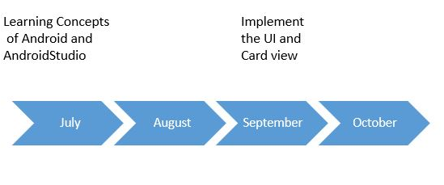

Chapter 4 Implementation Planning
4.1 Code
- Mainactivity.java
package com.example.fenil.voicetotext;

import android.support.v7.app.AppCompatActivity;
import android.os.Bundle;
import android.content.ActivityNotFoundException;
import android.content.Intent;
import android.speech.RecognizerIntent;
import android.view.View;
import android.widget.Button;
import android.widget.TextView;
import android.widget.Toast;

import java.util.ArrayList;
import java.util.Locale;

public class MainActivity extends AppCompatActivity {
private TextView resultTEXT;
@Override
protected void onCreate(Bundle savedInstanceState) {
super.onCreate(savedInstanceState);
setContentView(R.layout.activity_main);
resultTEXT = (TextView) findViewById(R.id.tvresult);
}
public void onButtonClick(View v) {
if (v.getId() == R.id.imageButton) {
promptSpeechInput();
}
}

private void promptSpeechInput() {
Intent i = new Intent(RecognizerIntent.ACTION_RECOGNIZE_SPEECH);
i.putExtra(RecognizerIntent.EXTRA_LANGUAGE_MODEL, RecognizerIntent.LANGUAGE_MODEL_FREE_FORM);
i.putExtra(RecognizerIntent.EXTRA_LANGUAGE, Locale.getDefault());
i.putExtra(RecognizerIntent.EXTRA_PROMPT, "Say somthing");
try {
startActivityForResult(i, 100);
} catch (ActivityNotFoundException e) {
Toast.makeText(MainActivity.this, "sorry but devise are not support your language", Toast.LENGTH_LONG).show();
}
}

public void onActivityResult(int request_code, int result_code, Intent i) {
super.onActivityResult(request_code, result_code, i);
switch (request_code) {
case 100:
if (result_code == RESULT_OK && i != null) {
ArrayList<String> result = i.getStringArrayListExtra(RecognizerIntent.EXTRA_RESULTS);
resultTEXT.setText(result.get(0));
}
}
}
}

- Activity_main.xml
<?xml version="1.0" encoding="utf-8"?>
<RelativeLayout xmlns:android="http://schemas.android.com/apk/res/android"
xmlns:app="http://schemas.android.com/apk/res-auto"
xmlns:tools="http://schemas.android.com/tools"
android:layout_width="match_parent"
android:layout_height="match_parent"
tools:context=".MainActivity">
<TextView
android:id="@+id/tvresult"
android:layout_width="wrap_content"
android:layout_height="wrap_content"
android:layout_centerHorizontal="true"
android:layout_centerVertical="true"
android:textAppearance="@style/TextAppearance.AppCompat.Medium" />
<ImageButton
android:id="@+id/imageButton"
android:layout_width="wrap_content"
android:layout_height="wrap_content"
android:layout_alignParentTop="true"
android:layout_centerHorizontal="true"
android:layout_marginTop="53dp"
android:onClick="onButtonClick"
app:srcCompat="@drawable/mic" />
<TextView
android:id="@+id/tv"
android:layout_width="wrap_content"
android:layout_height="wrap_content"
android:layout_alignParentTop="true"
android:layout_centerHorizontal="true"
android:layout_marginTop="22dp"
android:text="tap for recogniz to voice" />
</RelativeLayout>
4.2 Snapshots of project

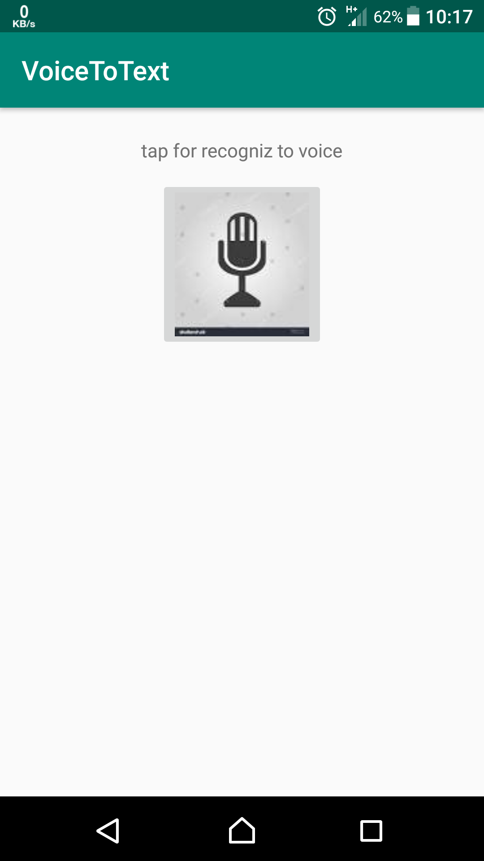

Fig 4.2.1

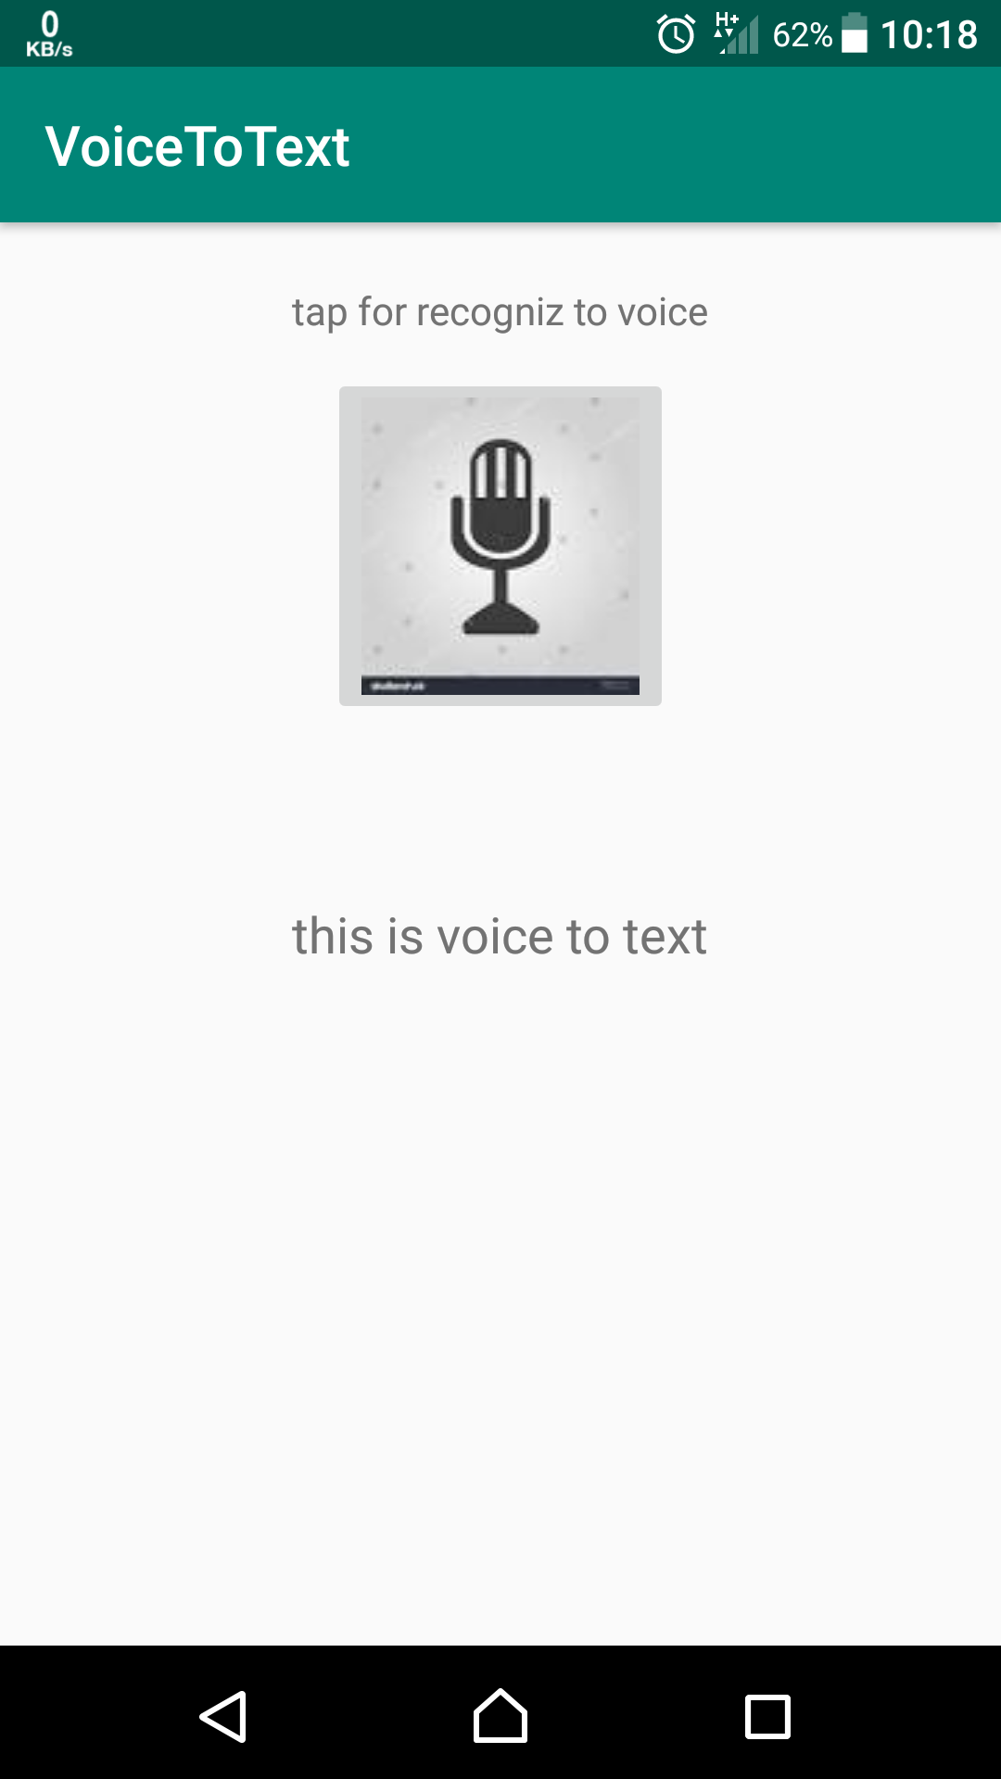

Fig 4.2.2

Chapter 5: Limitations and Future Enhancement

5.1 Limitations
- Lack of Accuracy and Misinterpretation
- Accents and Speech Recognition
- Physical Side Effects

5.2 Future Enhancement
- To implement in Gmail API.
- Implement App UI more Attractive.

Chapter 6: Conclusion
By this project, we can say that there would reduce writing skill of the uneducated people. Learning android was a great experience. Android studio is the best IDE for developing android application.

REFERENCE
- https://developer.android.com/studio/
- https://www.techwalla.com/articles/the-disadvantages-of-voice-recognition-software
- https://www.youtube.com/

